Server 2022 Users/Groups and NTFS Permissions
The purpose of this worksheet is to assist you in creating Users and Groups on the server. You will then use these Users and Groups as directed to demonstrate NTFS folder permissions.

Instructions
- Create the following Organizational Units (OUs), Users, and Groups on your Server 2022 VM.
  - You may assign them all the same password. Make it so the password never expires.
  - Because each of you will be working with the same server you will need to create unique OUs, Users, and Groups. One way to do this is to put your first name [fname] where indicated.
Organizational Units
Name
Oluwakayode Sales Users
Oluwakayode Marketing Users
Oluwakayode Managers

Users
Name | Username | OU | Password
Oluwakayode Boss | OluwakayodeBoss | Oluwakayode Managers | MSPress#1
Oluwakayode Salesbody | OluwakayodeSalesbody | Oluwakayode Sales Users | MSPress#1
Oluwakayode Marketer | OluwakayodeMarketer | Oluwakayode Marketing Users | MSPress#1

Groups
Name | Type | Members | OU
Oluwakayode Manager | Global Security | OluwakayodeBoss | Oluwakayode Managers
Oluwakayode Sales | Global Security | OluwakayodeSalesbody;  Oluwakayode Manager | Oluwakayode Sales Users
Oluwakayode Marketing | Global Security | OluwakayodeMarketer;  Oluwakayode Manager | Oluwakayode Marketing Users
- Take the following screenshots (or snips) and paste them below each description. The screenshots or snips will show the created OUs, the groups, and the members of each group as follows:
  - [fname] Managers OU showing [fname] Manager Security Group and [fname] Boss User. Ensure [fname] Boss is a member of the [fname] Manager Group.
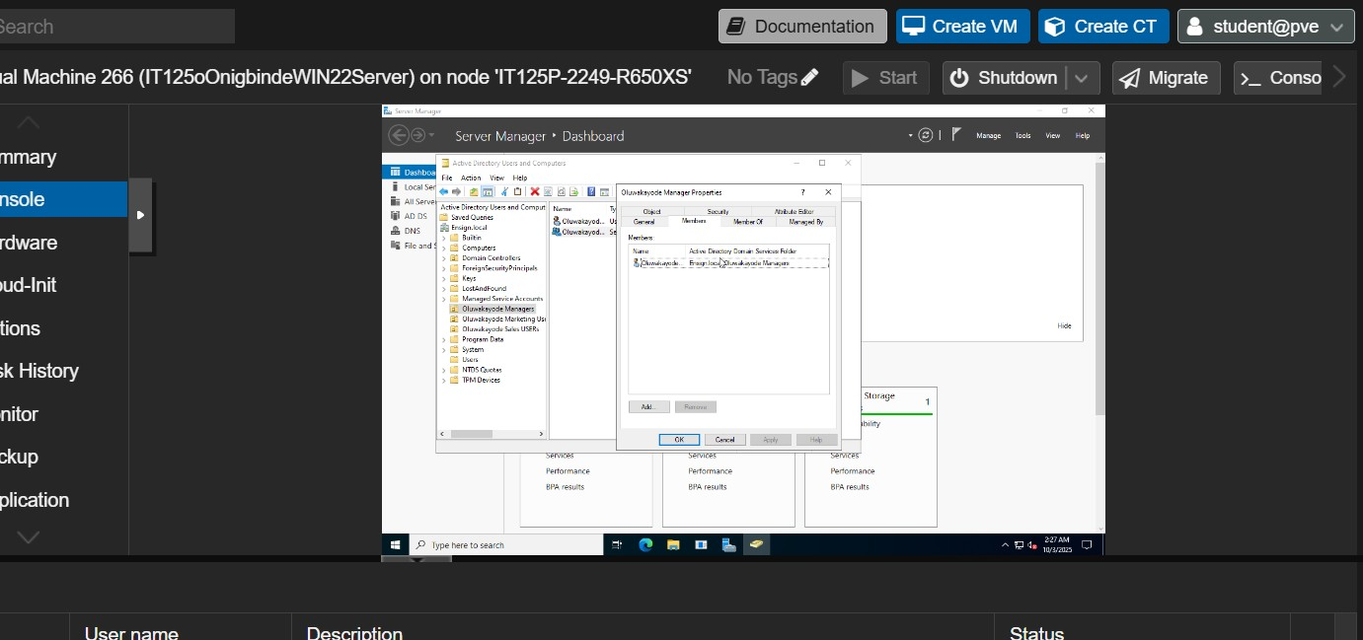

  - [fname] Marketing Users OU showing [fname] Marketing Security Group and [fname] Marketer User. Ensure [fname] Marketer is a member of the [fname] Marketing Group.
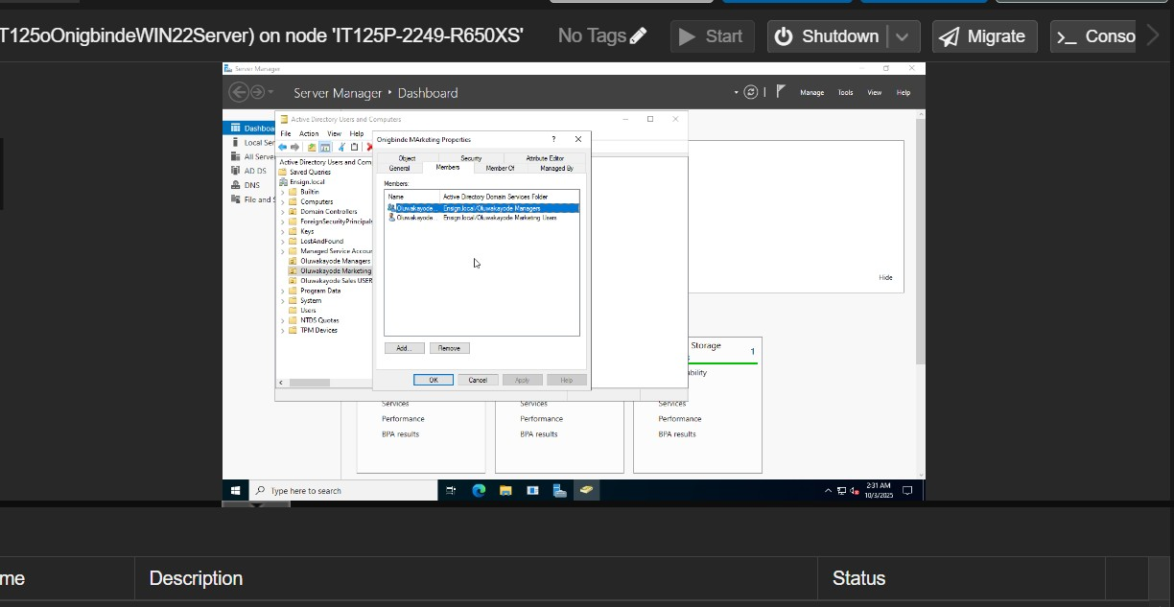

  - [fname] Sales Users OU showing [fname] Sales Security Group and [fname] Salesbody User. Ensure [fname] Salesbody is a member of the [fname] Sales Group.
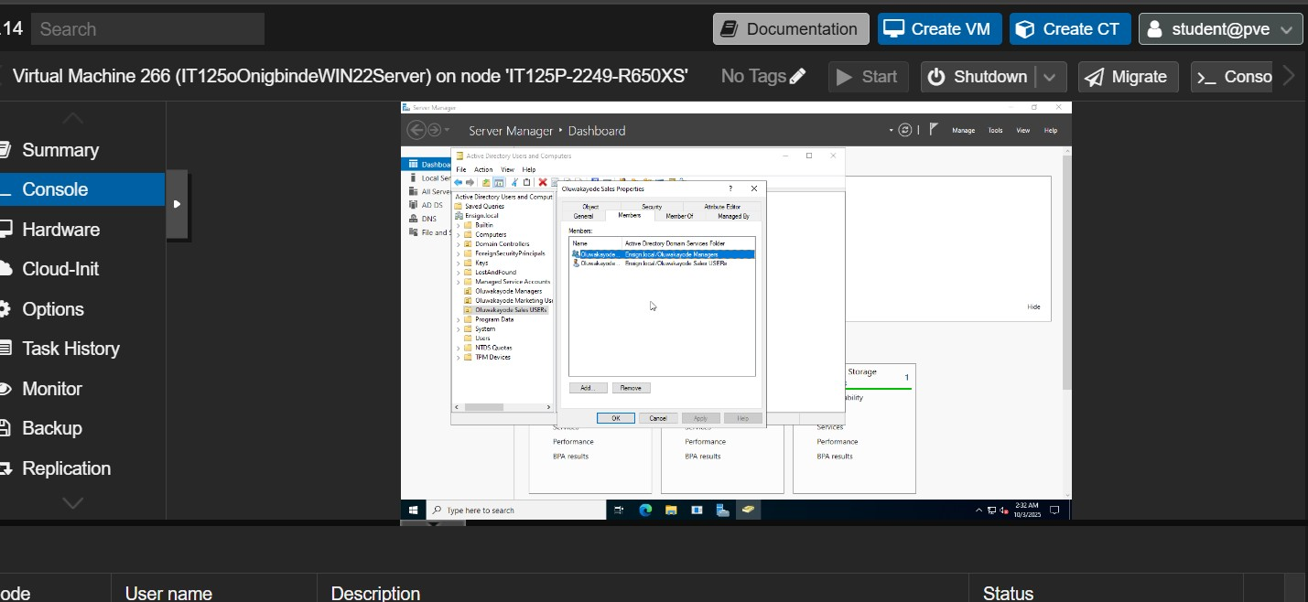

- On the C: drive of your Server 2022 Virtual Machine, create a folder named [fname] Share.
  - Share the folder with Everyone with Read/Write permissions.
  - Make note of the Network Path of the Share folder.
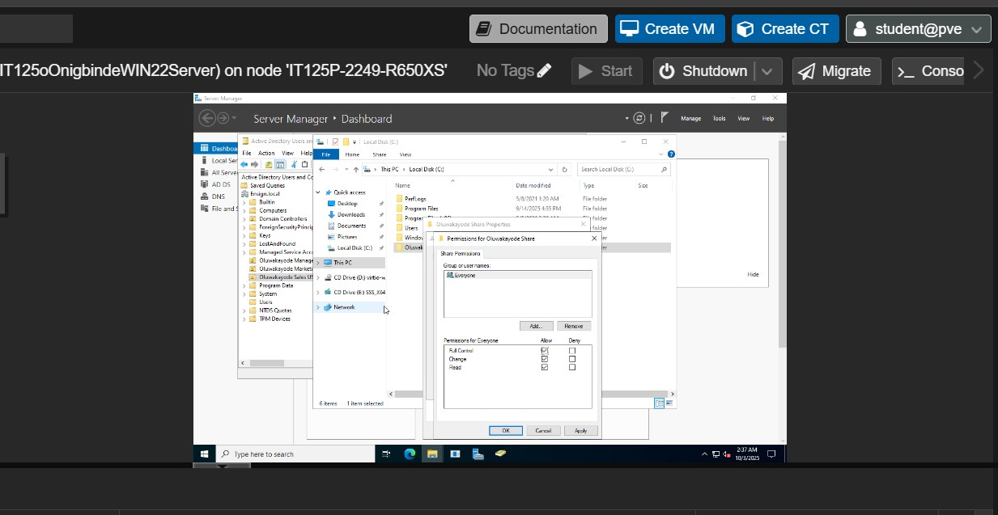
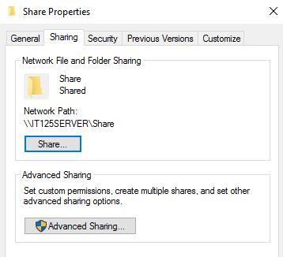
- Within the [fname] Share folder, create [fname] Sales and [fname] Marketing folders.
  - In the [fname] Sales folder, create a text file named Sales Document.
  - In the [fname] Marketing folder create a text file names Marketing Document.
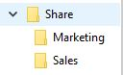
  - You will not need to set share permissions as they will inherit the permissions from the parent folder.
- You should have learned how to access shared files in previous projects. If you have forgotten how, please refer to earlier projects or research online how to accomplish this.
- Switch over to your Windows 11 machine and log in as [fname]Marketer. You should be able to access both of the documents.
- Switch back to the Server 2022 VM.
  - Edit the security setting of the [fname] Marketing folder.
  - Disable inheritance and convert inherited permissions to explicit permissions.
  - Remove the Everyone group.
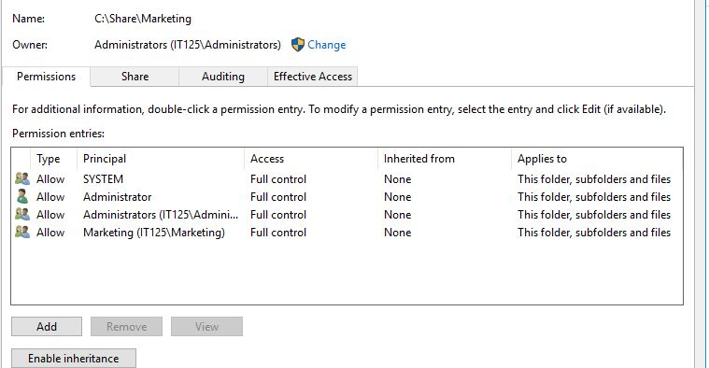
  - Add the [fname] Marketing security group and grant Full Control.
- Edit the security setting of the [fname] Sales folder.
  - Disable inheritance and convert inherited permissions to explicit permissions.
  - Remove the Everyone group.
  - Add the [fname] Sales security group and grant Full Control.
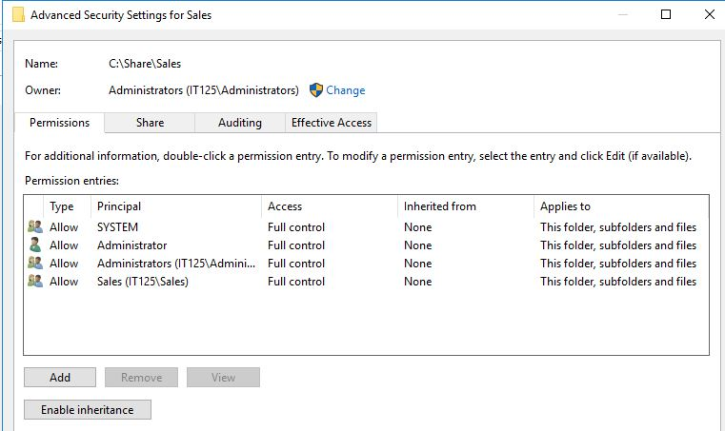

- Switch back to the Windows 11 VM.
  - Attempt to access the [fname] Marketing folder as before. You should be successful.
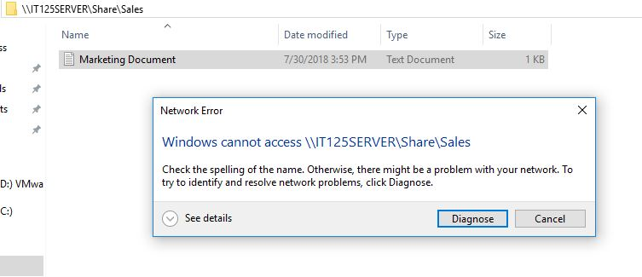
  - Attempt to access the [fname] Sales folder. You should get the following error:

You may only see the [fname] Marketing folder. Take a screenshot showing [fname] accessing the [fname] Marketing folder.
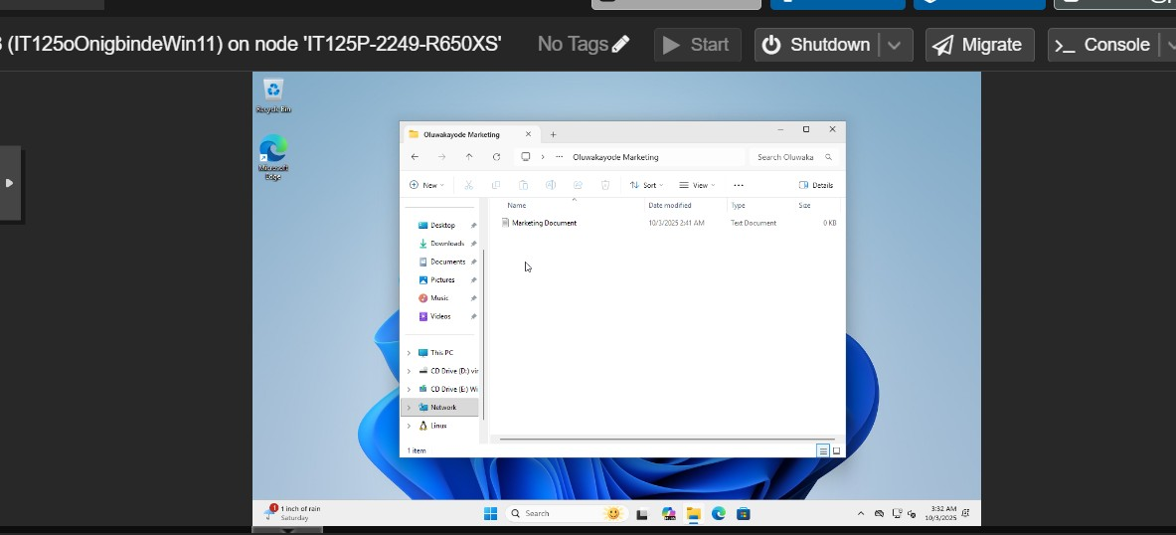

- Switch user to [fname] Salesbody.
  - Attempt to access the [fname] Sales folder. You should be successful. You should not even see the [fname] Marketing folder.
  - Take a screenshot of [fname] Salesbody attempting to access the [fname] Sales folder.
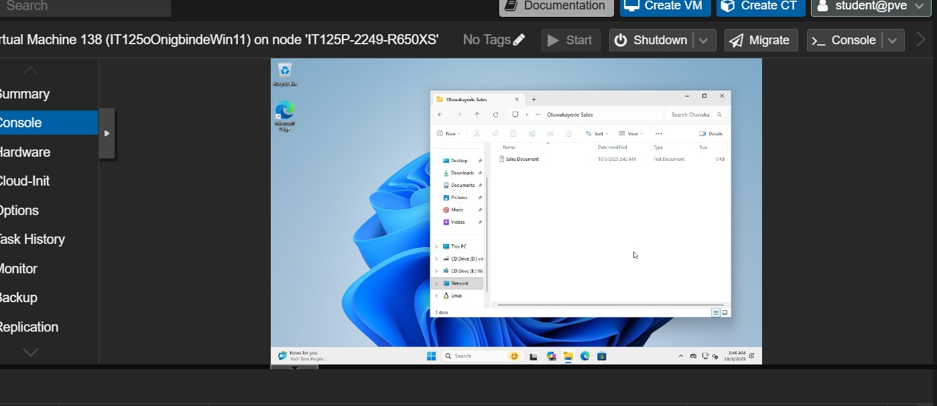:

- Switch user to [fname] Boss. This user should be able to access both folders and documents. Take the following screenshots:
  - [fname] Boss attempting to access [fname] Marketing folder.
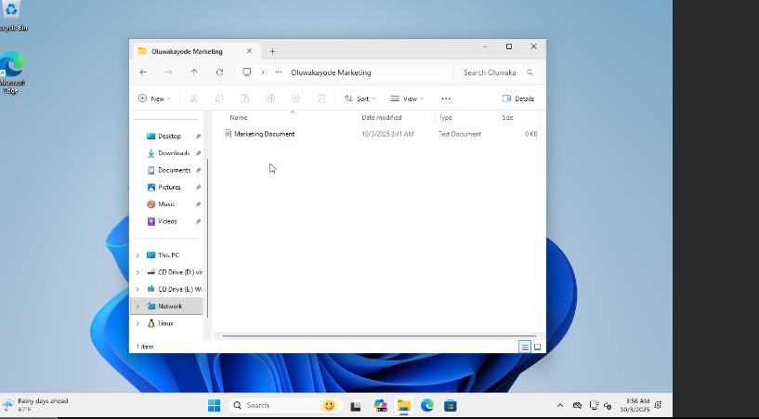

  - [fname] Boss attempting to access [fname] Sales folder.
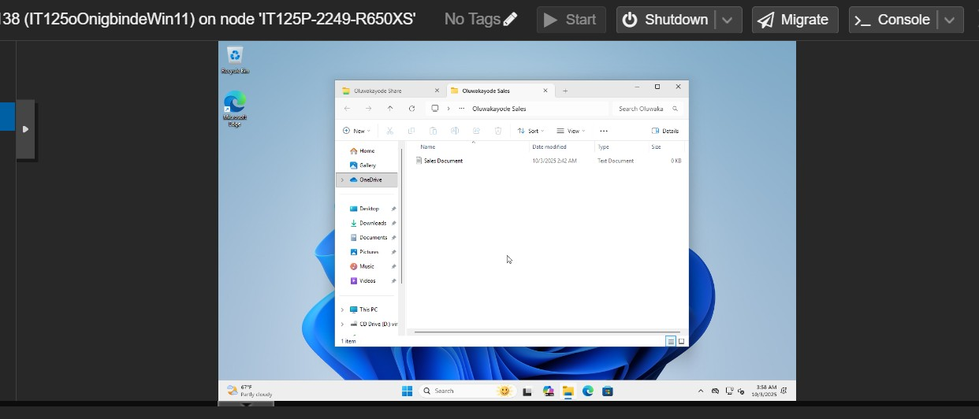

- Submit this completed worksheet in Canvas for assignment credit, including the 7 required screenshots in steps 2, 9, 10, and 11
REFLECTION:
Completing this project helped me better understand how user accounts, groups, and permissions work in Windows Server 2022. Creating Organizational Units, users, and security groups clarified how Active Directory organizes network resources. I also learned the difference between share and NTFS permissions, and how to apply them for secure access control. Testing access from different user accounts showed how permissions affect file visibility and security. At first, it was challenging to configure inheritance and understand the effect of removing “Everyone,” but experimenting made it clear. This exercise improved my confidence in managing users and securing network resources effectively.

